**Filtering**

**Topics Covered**

• Using an encoder to measure speed.

• Low-pass filters.

**Prerequisites**

• Integration laboratory experiment.

**1 Background**

A low-pass filter can be used to block out the high-frequency components of a signal. A first-order low-pass filter

transfer function has the form

*G*(*s*) =

*ωf*

*s* + *ωf*

*,* (1.1)

where *ωf* is the cut-off frequency of the filter in radians per seconds (rad/s). All higher frequency components of the signal will be attenuated by at least *−*3 dB *≈* 50%.

**2 In-Lab Exercises**

Based on the VI developed in Integration laboratory experiment, the goal is to design a VI that measures the servo velocity using the encoder as well as applying a low-pass filter to the acquired data as shown in Figure 2.1.

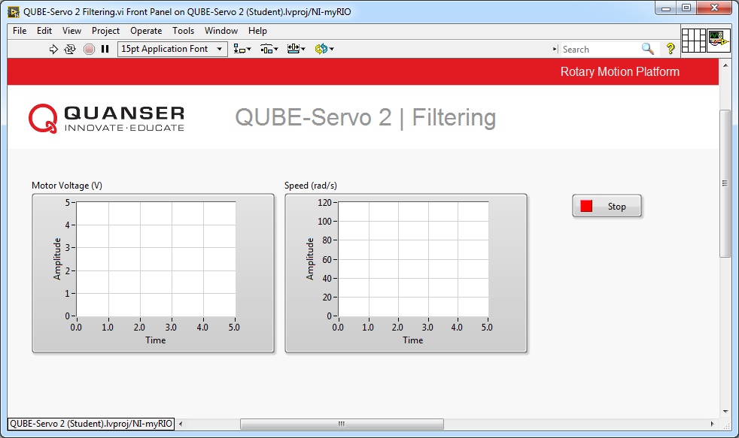

(a) Front Panel

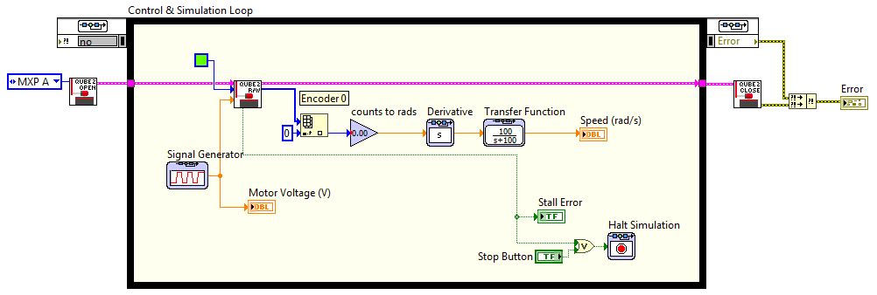

(b) Block Diagram

Figure 2.1: Measuring speed using the encoder

1. Take the model you developed in QUBE-Servo 2 Integration laboratory experiment. Change the encoder calibration gain to measure the gear position in radians instead of degrees as in the previous lab.

2. Build the VI shown in Figure 2.1 but, for now, do not include the Transfer Function block (will be added later).

• **Derivative**: Add a Derivative block to the encoder calibration Gain output to measure the gear speed using the encoder (in rad/s).

• **Plot**: Connect the output of the Derivative block to a Waveform Chart block. From the front panel, right- click the chart and set *Chart History Length* to 5,000. Set the *X-Axis* properties of the waveform chart as follows:

**–** Minimum: 0

**–** Maximum: 5

**–** Multiplier: 0.002 (must be the same as the control loop’s step size)

3. Add a Signal Generator from the *Control & Simulation* | *Simulation* | *Signal Generation* palette. Setup the Signal Generator to output a *square* voltage that goes from 1 V to 3 V at 0*.*4 Hz. Plot the motor voltage using a Waveform Chart block.

4. Run the VI. Examine the encoder speed response. Attach sample responses. They should look similar to

Figure 2.2.

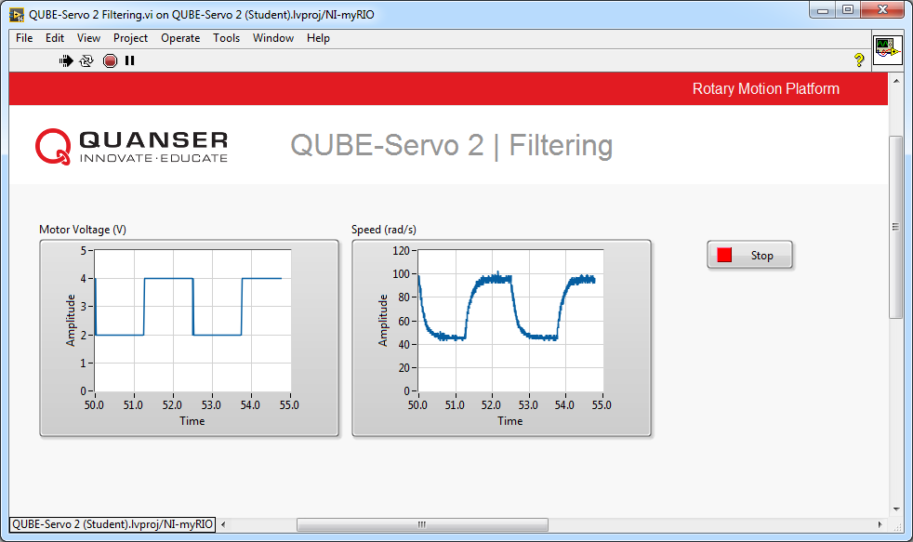

Figure 2.2: Measured servo speed using encoder

5. Explain why the encoder-based measurement is noisy.

**Hint:** Measure the encoder position measurement using a new Scope. Zoom up on the position response and remember that this later enters derivative. Is the signal continuous?

6. One way to remove some of the high-frequency components is adding a low-pass filter (LPF) to the derivative output. From the *Control & Simulation* | *Simulation* | *Continuous* palette, add a Transfer Function block after the derivative output and connect the output of the LPF to the Waveform Chart block. Set the Transfer Fcn block to

100/(*s* + 100), as illustrated in Figure 2.1.

7. Run the VI. Show the filtered encoder-based speed response and the motor voltage. Has it improved?

8. What is the cutoff frequency of the low-pass filter 100/(*s* + 100)? Give you answer in both rad/s and Hz.

9. Vary the cutoff frequency *ωf* between 10 and 200 rad/s (or 1*.*6 to 32 Hz). What effect does it have on the filtered response? Consider the benefit and the trade-off of lowering and increasing this parameter.

10. Click on the Stop button to stop the VI.

© 2017 Quanser Inc., All rights reserved.

Quanser Inc.

119 Spy Court Markham, Ontario L3R 5H6

Canada [info@quanser.com](mailto:info@quanser.com) Phone: 1-905-940-3575

Fax: 1-905-940-3576

Printed in Markham, Ontario.

For more information on the solutions Quanser Inc. offers, please visit the web site at:

[http://www.quanser.com](http://www.quanser.com/)

This document and the software described in it are provided subject to a license agreement. Neither the software nor this document may be used or copied except as specified under the terms of that license agreement. Quanser Inc. grants the following rights: a) The right to reproduce the work, to incorporate the work into one or more collections, and to reproduce the work as incorporated in the collections, b) to create and reproduce adaptations provided reasonable steps are taken to clearly identify the changes that were made to the original work, c) to distribute and publically perform the work including as incorporated in collections, and d) to distribute and publicly perform adaptations. The above rights may be exercised in all media and formats whether now known or hereafter devised. These rights are granted subject to and limited by the following restrictions: a) You may not exercise any of the rights granted to You in above in any manner that is primarily intended for or directed toward commercial advantage or private monetary compensation, and b) You must keep intact all copyright notices for the Work and provide the name Quanser Inc. for attribution. These restrictions may not be waved without express prior written permission of Quanser Inc.